ENTERPRISE MULTI-SITE NETWORK & SECURITY LAB

Internship Technical Report
Intern Name: Abdimalik Yusuf Mohamud
Role: Network & Security Intern
Environment: Self-Directed Enterprise Infrastructure Lab
Reporting Period: Month 1
Report Type: Technical Infrastructure Deployment Report

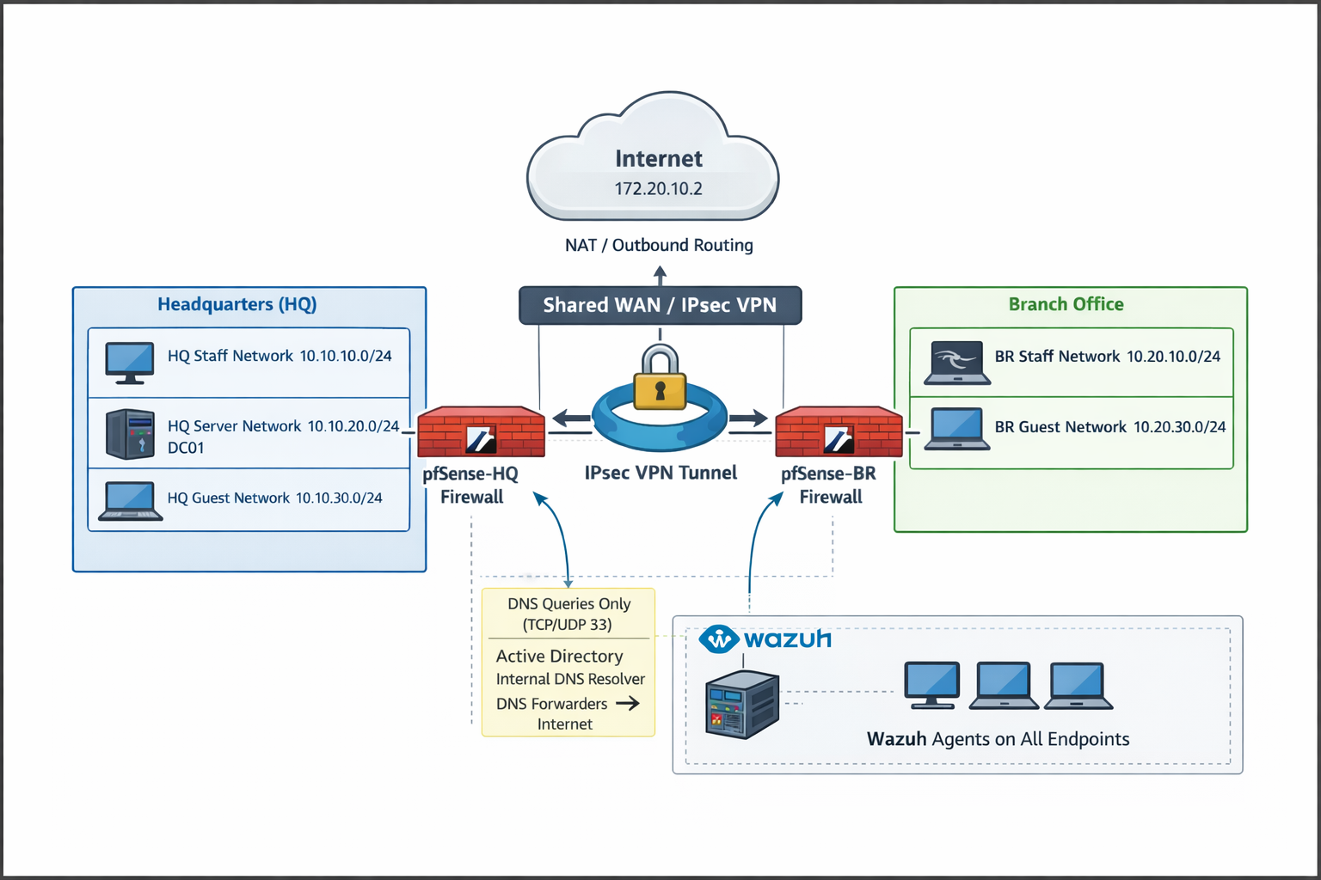

TABLE OF CONTENTS
Contents
ENTERPRISE MULTI-SITE NETWORK & SECURITY LAB 1
Internship Technical Report 1
TABLE OF CONTENTS 2
1. Executive Summary 2
2. Scope of Work 3
3. Network Segmentation Strategy 3
3.1 Headquarters Networks 3
3.2 Branch Networks 3
Core Components 4
4. pfSense Firewall Deployment 4
4.1 pfSense-HQ Responsibilities 4
4.2 pfSense-BR Responsibilities 4
5. Routing & Gateway Logic 5
6. IPsec Site-to-Site VPN Implementation 5
6.1 Configuration 5
6.2 Verification 6
7. Outbound NAT & Internet Breakout Configuration 6
7.1 NAT Design 6
7.2 Internet Outage Incident 6
8. Active Directory & DNS Deployment 7
8.1 DC01 Configuration 7
8.2 DNS Architecture 7
9. Endpoint Integration & Domain Enrollment 8
9.1 HQ Endpoints 8
9.2 Branch Endpoints 8
10. Wazuh SIEM Deployment – Monitoring Baseline 8
10.1 Wazuh Manager Deployment 8
10.2 Agent Enrollment 9
10.3 Telemetry Baseline Enabled 9
11. Final Operational State 10
12. Skills & Technical Competencies Developed 10

1. Executive Summary
During Month 1 of the internship, I designed, implemented, and validated a complete multi-site enterprise infrastructure simulating a small-to-medium business environment with Headquarters (HQ) and a Branch office.
The environment includes:
- Segmented internal networks (Staff, Servers, Guests)
- Dual pfSense enterprise firewalls
- Policy-based IPsec site-to-site VPN
- Centralized Active Directory with integrated DNS
- Controlled internet breakout via stateful firewalling and outbound NAT
- Centralized endpoint monitoring using Wazuh SIEM
A significant technical milestone during this month was diagnosing and resolving a full internal internet outage caused by a disabled firewall engine on pfSense. Although routing and VPN appeared functional, outbound NAT was not being enforced. Using packet capture analysis, NAT rule validation, and firewall state inspection, the issue was identified and resolved, restoring stable internet connectivity.
In parallel, a Wazuh Manager was deployed within the HQ server network and all endpoints across both sites were enrolled as agents. This established centralized telemetry collection, forming the foundation for advanced detection engineering and SOC-style monitoring planned for Month 2.

2. Scope of Work
The objectives for Month 1 were defined as infrastructure-focused and foundational:
- Design a segmented enterprise network topology
- Deploy pfSense firewalls at HQ and Branch
- Configure IPsec site-to-site VPN connectivity
- Implement routing and firewall policy controls
- Deploy Active Directory Domain Services
- Configure integrated DNS with forwarders
- Join endpoints to the domain across sites
- Implement secure outbound NAT
- Deploy Wazuh SIEM and enroll all endpoints
- Troubleshoot and resolve real-world connectivity failure

3. Network Segmentation Strategy
Segmentation was implemented to enforce trust boundaries and reduce attack surface.

3.1 Headquarters Networks

Network | Subnet | Purpose
HQ_STAFF | 10.10.10.0/24 | Corporate users
HQ_SERVERS | 10.10.20.0/24 | AD, DNS
HQ_GUEST | 10.10.30.0/24 | Internet-only

3.2 Branch Networks

Network | Subnet | Purpose
BR_STAFF | 10.20.10.0/24 | Branch users
BR_GUEST | 10.20.30.0/24 | Internet-only
Design principles:
- Staff networks can access required services only
- Server network isolated from guests
- Guest networks restricted to internet-only access
- No implicit trust between subnets
- Explicit firewall rules for all inter-network communication
This mirrors VLAN-based enterprise design and limits lateral movement potential.

Core Components
- pfSense-HQ (Edge firewall + VPN endpoint)
- pfSense-BR (Branch firewall + VPN endpoint)
- DC01 (Domain Controller + DNS)
- Wazuh Manager (HQ_SERVERS network)
- Staff endpoints (HQ and BR)
- Guest networks (isolated internet-only)
[INSERT DIAGRAM: Multi-Site Architecture Overview]

4. pfSense Firewall Deployment
Two independent pfSense firewalls were deployed.

4.1 pfSense-HQ Responsibilities
- Inter-VLAN routing
- Firewall rule enforcement
- IPsec VPN endpoint
- Outbound NAT
- DHCP services
- Internet breakout
- Central routing decisions

4.2 pfSense-BR Responsibilities
- Branch routing
- Local firewall policies
- IPsec VPN endpoint
- Controlled internet breakout
- DHCP services
Firewall rules were explicitly configured to allow:
- Staff ↔ Servers
- Branch Staff ↔ HQ Servers (over VPN)
- Staff ↔ Staff (cross-site)
- Guests → Internet only
Nothing was implicitly allowed.
[INSERT SCREENSHOT: Firewall Rules]

5. Routing & Gateway Logic
All endpoints were configured with:
- One default gateway → local pfSense LAN IP
- DNS → DC01
Endpoints have no awareness of:
- VPN topology
- WAN routing
- Internet NAT behavior
pfSense performs:
- Internal routing
- VPN routing decisions
- NAT translation
- Stateful return tracking
Routing decisions:
- Internal → Internal = direct
- Internal → Remote Site = IPsec tunnel
- Internal → Internet = WAN + NAT

6. IPsec Site-to-Site VPN Implementation

6.1 Configuration
Policy-based IPsec was deployed.
Phase 1:
- Secure tunnel between HQ and Branch WAN interfaces
Phase 2:
- Explicit subnet pairs:
  - 10.10.10.0/24 ↔ 10.20.10.0/24
  - 10.10.20.0/24 ↔ 10.20.10.0/24

6.2 Verification
- Tunnel established successfully
- Packet capture confirmed encrypted traffic
- Cross-site domain authentication successful
- Branch endpoints successfully authenticated against HQ DC

7. Outbound NAT & Internet Breakout Configuration

7.1 NAT Design
Manual Outbound NAT was implemented on pfSense-HQ.
Explicit rules created for:
- 10.10.10.0/24
- 10.10.20.0/24
- (Additional internal subnets where required)
Translation Address:
- WAN Interface Address

7.2 Internet Outage Incident
Symptoms observed:
- No internal host could ping 8.8.8.8
- DNS resolution failed
- VPN traffic still operational
- pfSense itself could reach the internet
Investigation steps:
- Packet capture on LAN interface
- Packet capture on WAN interface
- NAT rule verification
- Firewall rule inspection
- pfctl rule analysis
Discovery:
Firewall engine was disabled under:
System → Advanced → Firewall & NAT
Impact:
- NAT rules were present but not enforced
- Private IP addresses exited WAN unmodified
- Return traffic dropped by upstream network
Resolution:
- Re-enabled firewall engine
- Reset state table
- Verified WAN packet translation
Internet connectivity restored immediately.

8. Active Directory & DNS Deployment

8.1 DC01 Configuration
- Windows Server
- Static IP: 10.10.20.10
- Roles:
  - Active Directory Domain Services
  - DNS Server

8.2 DNS Architecture
All domain members use DC01 as primary DNS.
Forwarders configured:
- 1.1.1.1
- 8.8.8.8
This allows:
- Internal domain resolution
- External name resolution
- Proper SRV record discovery
- Cross-site authentication
Key concept learned:

9. Endpoint Integration & Domain Enrollment

9.1 HQ Endpoints
- Successfully joined to domain
- Verified domain login
- Verified internal DNS
- Verified internet access

9.2 Branch Endpoints
- Joined domain over VPN
- Authenticated to HQ DC
- Cross-site Kerberos and DNS verified
- Internet breakout functioning independently
This confirms:
- Inter-site trust
- VPN routing integrity
- DNS functionality across sites

10. Wazuh SIEM Deployment – Monitoring Baseline
Wazuh deployment was completed during Month 1 to establish centralized monitoring.

10.1 Wazuh Manager Deployment
- Installed within HQ_SERVERS network
- Dedicated server instance
- Accessible via web dashboard
[INSERT SCREENSHOT: Wazuh Dashboard Overview]

10.2 Agent Enrollment
Agents deployed to:
- HQ Staff machines
- Branch Staff machines
- Domain Controller
- Additional servers (where applicable)
All agents successfully registered with manager.
[INSERT SCREENSHOT: Agents List]

10.3 Telemetry Baseline Enabled
Collected data includes:
- Windows Security Event Logs
- System logs
- Authentication events
- Failed logon attempts
- Basic file integrity monitoring
- Linux syslog (where applicable)
Connectivity validated by:
- Agent heartbeat confirmation
- Log ingestion visible in dashboard
- Test event generation

11. Final Operational State
Component | Status
HQ Routing | Operational
Branch Routing | Operational
IPsec VPN | Stable
Active Directory | Operational
DNS Resolution | Functional
Outbound NAT | Functional
Internet Access | Verified
Firewall Enforcement | Enabled
Wazuh Manager | Operational
Agents Reporting | Verified

12. Skills & Technical Competencies Developed
- Enterprise firewall configuration
- Manual outbound NAT implementation
- IPsec VPN deployment
- Routing & gateway design
- Packet capture analysis
- Active Directory deployment
- DNS troubleshooting
- Multi-site authentication validation
- SIEM deployment (Wazuh)
- Endpoint telemetry validation
- Incident root-cause investigation

